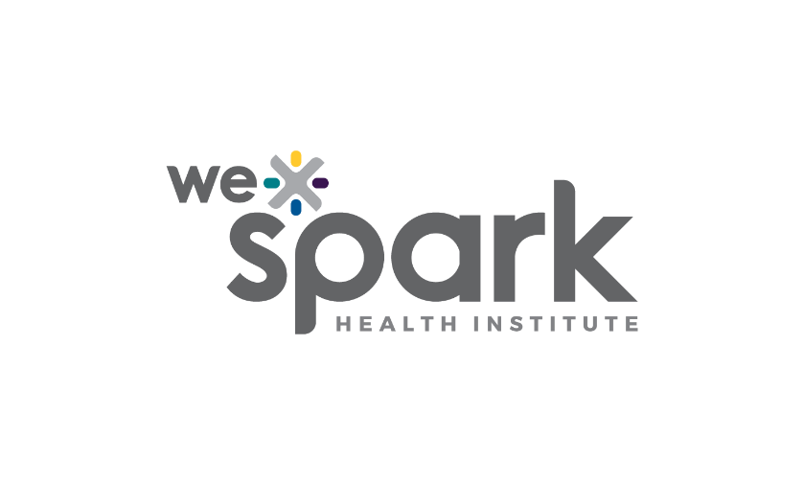
Funding Organization: WE-SPARK Health Institute

Program Name: IDEA Grants

Program Launch Date: February 28, 2025

2025 Application

Due Monday May 5th, 2025 by 5PM
Submit Full Application online through Airtable here: WE-SPARK IDEA Grant 2025 Full Application
Convert this word document to a PDF prior to submission.

Principal Applicant

Surname, Given name: |  | Institution:
Faculty/ Department: |  | Email:

Project Information
Project Title:

Project Idea (Maximum 1 page)

Describe the problem, including background information, existing gaps in knowledge or practice, and why this challenge is important to solve. Also outline your research idea and describe how your approach will address the identified challenge.

Implementation Plan (Maximum 1.5 page)

Describe how you will execute your idea. Provide a plan outlining the key steps, timelines, and required resources. Explain your methodologies, including how data will be collected, analyzed, or applied (if applicable). Highlight partnerships or collaborations that will support your project. Address potential challenges and risks, along with strategies to mitigate them. Finally, describe how you will measure success and evaluate the impact of your work.

Impact (Maximum 0.5 page)

Identify who will benefit from your project and how. Discuss the intended impacts on individuals, communities, or systems. If applicable, include how your project aligns with broader research, healthcare, or community priorities.

Budget

Briefly describe your budget and major use of funds. Budgets will be evaluated based on feasibility.

Direct costs of research | Total
Salaries (e.g., short-term positions)
Materials and supplies
Other (e.g., participant incentives, gifts for Indigenous Elders):
Total Request

Team (Maximum 1 page)

In one page, describe the overall project team. Provide the following details for each team member:
- Full name
- Role (i.e., principal applicant, co-applicant, or collaborator)
- Expertise, experience, personnel, and/or facilities that makes the team member a perfect fit for their responsibilities.

CVs

Attach a CIHR styled Biosketch CV along with this application for the Principal Applicant. Co-Applicants and Collaborators are not required to submit CVs.

Supplementary Pages (Optional – maximum 2 pages)

You may include up to two (2) supplementary pages at the end of this application. These pages may include, but are not limited to, figures, tables, and/or instruments relevant to the research project. Formatting requirements do not apply. Include the supplementary pages at the end of the application.

